

**WEATHER FORECASTING USING PYTHON**

# A MINOR PROJECT - II REPORT

***Submitted by***

T.PAVITHRA - 927621BEC144

M.POOJA SHREE - 927621BEC146

V.S.POORVAJA - 927621BEC147

M.PRAVEENA - 927621BEC152

**BACHELOR OF ENGINEERING**

in

**DEPARTMENT OF ELECTRONICS AND COMMUNICATION ENGINEERING**

**M.KUMARASAMY COLLEGE OF ENGINEERING**

(Autonomous)

**KARUR – 639 113**

**April 2023**

# M.KUMARASAMY COLLEGE OF ENGINEERING, KARUR

## BONAFIDE CERTIFICATE

Certifiedthatthis 18ECP104L - Minor Project II report “WEATHER FORECASTING USING PYTHON**”** is the bonafide workof “**PAVITHRA. T (927621BEC144), POOJA SHREE. M (927621BEC146), POORVAJA .V. S**

**(927621BEC147), PRAVEENA. M (927621BEC152)”** who carried out the project work under my supervision in the academic year 2022-2023 Even sem.

**SIGNATURE SIGNATURE**

**Dr.S.PALANIVEL RAJAN, M.E., M.B.A., Ph.D., Dr.A.KAVITHA, ME.,Ph.D..**

**D.Litt (USA).,**

**HEAD OF THE DEPARTMENT, SUPERVISOR,**

Professor, Professor,

Department of Electronics and Department of Electronics and

Communication Engineering, Communication Engineering,

M.Kumarasamy College of Engineering, M.Kumarasamy College of Engineering,

Thalavapalayam, Thalavapalayam,

Karur-639113. Karur-639113.

This Minor project-II report has been submitted for the 18ECP104L – Minor

Project-IIReview held at M.Kumarasamy College of Engineering, Karur on ________

**PROJECT COORDINATOR**

## INSTITUTION VISION AND MISSION

**Vision**

To emerge as a leader among the top institutions in the field of technical education.

### Mission

**M1:** Produce smart technocrats with empirical knowledge who can surmount the global challenges.

**M2:** Create a diverse, fully -engaged, learner -centric campus environment to provide quality education to the students.

**M3:** Maintain mutually beneficial partnerships with our alumni, industry and professional associations

## DEPARTMENT VISION, MISSION, PEO, PO AND PSO

### Vision

### To empower the Electronics and Communication Engineering students with emerging technologies, professionalism, innovative research and social responsibility.

### Mission

**M1:** Attain the academic excellence through innovative teaching learning process, research areas & laboratories and Consultancy projects.

**M2:** Inculcate the students in problem solving and lifelong learning ability.

**M3:** Provide entrepreneurial skills and leadership qualities.

**M4:** Render the technical knowledge and skills of faculty members.

### Program Educational Objectives

|  |  |
| --- | --- |
| **PEO1:** | **Core Competence:** Graduates will have a successful career in academia or industry associated with Electronics and Communication  Engineering |
| **PEO2:** | **Professionalism:** Graduates will provide feasible solutions for the challenging problems through comprehensive research and innovation in the allied areas of Electronics and Communication Engineering. |
| **PEO3:** | **Lifelong Learning:** Graduates will contribute to the social needs |

through lifelong learning, practicing professional ethics and leadership quality

### Program Outcomes

**PO 1: Engineering knowledge:** Apply the knowledge of mathematics, science, engineering fundamentals, and an engineering specialization to the solution of complex engineering problems.

**PO 2: Problem analysis:** Identify, formulate, review research literature, and analyze complex engineering problems reaching substantiated conclusions using first principles of mathematics, natural sciences, and engineering sciences.

**PO 3: Design/development of solutions:** Design solutions for complex engineering problems and design system components or processes that meet the specified needs with appropriate consideration for the public health and safety, and the cultural, societal, and environmental considerations.

**PO 4: Conduct investigations of complex problems:** Use research-based knowledge and research methods including design of experiments, analysis and interpretation of data, and synthesis of the information to provide valid conclusions.

**PO 5: Modern tool usage:** Create, select, and apply appropriate techniques, resources, and modern engineering and IT tools including prediction and modeling to complex engineering activities with an understanding of the limitations.

**PO 6: The engineer and society:** Apply reasoning informed by the contextual knowledge to assess societal, health, safety, legal and cultural issues and the consequent responsibilities relevant to the professional engineering practice.

**PO 7: Environment and sustainability:** Understand the impact of the professional engineering solutions in societal and environmental contexts, and demonstrate the knowledge of, and need for sustainable development.

**PO 8: Ethics:** Apply ethical principles and commit to professional ethics and responsibilities and norms of the engineering practice.

**PO 9: Individual and team work:** Function effectively as an individual, and as a member or leader in diverse teams, and in multidisciplinary settings.

**PO 10: Communication:** Communicate effectively on complex engineering activities with the engineering community and with society at large, such as, being able to comprehend and write effective reports and design documentation, make effective presentations, and give and receive clear instructions.

**PO 11: Project management and finance:** Demonstrate knowledge and understanding of the engineering and management principles and apply these to one’s own work, as a member and leader in a team, to manage projects and in multidisciplinary environments.

**PO 12: Life-long learning:** Recognize the need for, and have the preparation and ability to engage in independent and life-long learning in the broadest context of technological change.

### Program Specific Outcomes

**PSO1:** Applying knowledge in various areas, like Electronics, Communications, Signal processing, VLSI, Embedded systems etc., in the design and implementation of Engineering application.

**PSO2:** Able to solve complex problems in Electronics and Communication Engineering with analytical and managerial skills either independently or in team using latest hardware and software tools to fulfil the industrial expectations.

|  |  |
| --- | --- |
| **Abstract** | **Matching with POs, PSOs** |
| Weather forecasting, temperature; short range, governments, tropical storms, challenging task, forecasting. | PO1, PO2, PO3, PO5, PO6, PO7, PO8,  PO9, PO10, PO11, PO12, PSO1, PSO2 |

**ACKNOWLEDGEMENT**

Our sincere thanks to **Thiru.M.Kumarasamy, Chairman** and **Dr.K.Ramakrishnan, Secretary** of **M.Kumarasamy College of** **Engineering** for providing extraordinary infrastructure, which helped us to complete this project in time.

It is a great privilege for us to express our gratitude to **Dr.B.S.Murugan., B.Tech., M.Tech., Ph.D.,** **Principal** for providing us right ambiance to carry out this project work.

We would like to thank **Dr.S.Palanivel Rajan, M.E., M.B.A., Ph.D., D.Litt (USA)., Professor and Head**, **Department of Electronics and Communication Engineering** for his unwavering moral support and constant encouragement towards the completion of this project work.

We offer our wholehearted thanks to our **Project Supervisor, Dr.A.KAVITHA, ME.,Ph.D., Professor,** Department of Electronics and Communication Engineering for his precious guidance, tremendous supervision, kind cooperation, valuable suggestions and support rendered in making our project to be successful.

We would like to thank our **Minor Project Co-ordinator**, **Dr.E.Dinesh, M.E., Ph.D., Associate Professor**, Department of Electronics and Communication Engineering for his kind cooperation and culminating in the successful completion of this project work. We are glad to thank all the Faculty Members of the Department of Electronics and Communication Engineering for extending a warm helping hand and valuable suggestions throughout the project. Words are boundless to thank our Parents and Friends for their motivation to complete this project successfully.

**ABSTRACT**

Weather forecasting is the application of science and technology to predict the state of the atmosphere for a given location. Ancient weather forecasting methods usually relied on observed patterns of events, also termed pattern recognition. For example, it might be observed that if the sunset was particularly red, the following day often brought fair weather. However, not all of these predictions prove reliable. Here this system will predict weather based on parameters such as temperature, humidity and wind. User will enter current temperature, humidity and wind.

System will take this parameter and will predict weather (rainfall in inches) from previous data in database (dataset). The role of the admin is to add previous weather data in database, so that system will calculate weather (estimated rainfall in inches) based on these data. The climatic condition parameters are based on the temperature, wind, humidity, rainfall and size of data set. The data is collected from the temperature and humidity sensor called DHT11 sensor, which helps in detecting the temperature and humidity values of a particular region or location. The raspberry pi is used for storing the collected data to the cloud, with the help of Ethernet shield for uploading the data online. The data stored in cloud is generated in the form of CSV, JSON, XML files which is used for further analysis. The correlation analysis of the parameters helps in predicting the future values. The ARIMA model that gives better results for time-series data is used for predicting the values for forthcoming.

Keywords- Weather forecasting, temperature; short range, governments, tropical storms, challenging task, forecasting.

**TABLE OF CONTENTS**

**CHAPTER PAGE**

**CONTENTS**

**No. No.**

**Institution Vision and Mission** iii

**Department Vision and Mission** iii

**Department PEOs, POs and PSOs** iv

**Abstract** viii

**List of Figures** x

**List of Abbreviations** xi

1. **INTRODUCTION 1**
2. **LITERATURE SURVEY 3**
3. **EXISTING METHODS AND ITS**

**DRAWBACKS 6**

1. **PROPOSED METHOD 9**
2. **MODULES AND PROJECT DESCRIPTION 10**
3. **CODE FOR WEATHER FORECASTING 21**

**7 RESULT AND DISCUSSION 23**

**8 CONCLUSION 25**

**REFERENCES 26**

**OUTCOME 28**

LIST OF FIGURES

**FIGURE No. TITLE PAGE No.**

5.1 Mean Temperature12

5.2 Humidity 13

5.3 Windspeed 15

5.4 Relation between temperature

And humidity 15

5.5 Temperature change 17

5.6 Facebook prophet model 19

7.1 Running of weather 22

7.2 Output 23

**LIST OF ABBREVIATIONS**

|  |  |  |  |  |
| --- | --- | --- | --- | --- |
| **ACRONYM** | |  | | **ABBREVIATION** |
| **ARMA** | |  | Average Models with Neural Network Models Autoregressive Moving Average | |
| **RMSE** | |  | Root Mean Square Error | |
| **NWS** | |  | National Weather Service | |
| **NWP** | |  | Numerical Weather Prediction | |
| **GCM** | |  | Global Circulation Models | |
| **NCMRWF** | |  | National Centre for Medium Range Weather Forecasting | |
|  | |  |  | |
|  | |  | |  |
|  | |  | |  |
|  |  | | |  |
|  | |  | |  |
|  | |  | |  |

**CHAPTER 1**

**INTRODUCTION**

Weather forecasting is the prediction of the state of the atmosphere for a given location using the application of science and technology. This includes temperature, rain, cloudiness, wind speed, and humidity. Weather warnings are a special kind of short-range forecast carried out for the protection of human life. Once calculated manually based mainly upon changes in [barometric pressure](https://en.wikipedia.org/wiki/Atmospheric_pressure), current weather conditions, and sky condition or cloud cover, weather forecasting now relies on [computer-based models](https://en.wikipedia.org/wiki/Numerical_weather_prediction) that take many atmospheric factors into account. Human input is still required to pick the best possible model to base the forecast upon, which involves pattern recognition skills, [teleconnections](https://en.wikipedia.org/wiki/Teleconnection), knowledge of model performance, and knowledge of model biases.[1]

The inaccuracy of forecasting is due to the [chaotic](https://en.wikipedia.org/wiki/Chaos_theory) nature of the atmosphere, the massive computational power required to solve the equations that describe the atmosphere, the land, and the ocean, the error involved in measuring the initial conditions, and an incomplete understanding of atmospheric and related processes. Hence, forecasts become less accurate as the difference between current time and the time for which the forecast is being made (the range of the forecast) increases. The use of ensembles and model consensus helps narrow the error and provide confidence in the forecast.

There is a vast variety of end uses for weather forecasts. [Weather warnings](https://en.wikipedia.org/wiki/Weather_warning) are important because they are used to protect life and property. Forecasts based on temperature and [precipitation](https://en.wikipedia.org/wiki/Precipitation_(meteorology)) are important to agriculture, and therefore to traders within commodity markets. Temperature forecasts are used by utility companies to estimate demand over coming days.

On an everyday basis, many people use weather forecasts to determine what to wear on a given day. Since outdoor activities are severely curtailed by heavy rain, snow and [wind chill](https://en.wikipedia.org/wiki/Wind_chill), forecasts can be used to plan activities around these events, and to plan ahead and survive them.[2]

Weather forecasting is a part of the economy.

Features Weather Forecast Project in Python Django:

* Time to time update weather
* Temperature Update
* Last 7 days data Predict
* change weather in every hours as according to weather changes.
* provide accurate data information about weather.
* user can search weather anytime and anywhere.
* any places data can be search and provide information as according to weather.
* help user to travel.
* help User to future plans for holidays

**CHAPTER 2**

**LITERATURE REVIEW**

A. Autoregressive Integrated Moving Average Models with Neural Network Models Autoregressive Moving Average (ARMA) model for wind speed forecasting was used. The predicted values of variance and wind speed was acceptable both for short-term and long-term prediction with an assured interval of 95%. In the last decade Artificial Neural Networks (ANNs) gain more attention for weather forecasting and some other disciplines that used time series data. Hybrid model of ARIMA and ANN was used for the prediction of wind speed. The ARIMA models were used to predict the wind speed. With the assumption that the generated error by ARIMA could preserve the nonlinear behavior; ANN were fabricated to reduce the final errors. Considering the advantages of ANN, it is integrated with ARIMA time series model. The aim was to develop models for forecasting the next day’s close value of Bombay Stock Exchange. In ANN_ARIMA future forecasted value was predicted using ANN and its residuals were inputted to ARIMA for error forecasting. The output from both models was summed up to get the final forecasted value. ARIMA_ANN were modeled by training the data using ARIMA model and forecasted value and then the residual generated were passed to ANN for forecasting error forecast. Both the values are added to produce the final forecasted value. Trend comparisons of the hybridized models were made with distinct and integrated approaches of ANN and ARIMA. Measurements, strength and weaknesses of ANN and ARIMA Performance of the models was evaluated by Average Absolute Error (AAE), Root Mean Square Error (RMSE) and Mean Absolute Percentage Error (MAPE). The better performances of the integrated models over the single method have been evidence from the result. There are many research papers that have been published related to predicting the weather. A paper was published on ‘The Weather Forecast Using Data Mining Research Based on Cloud Computing’ This paper proposes a modern method to develop a service oriented architecture for the weather information systems which forecast weather using these data mining techniques. This can be carried out by using Artificial Neural Network and Decision tree Algorithms and meteorological data collected in Specific time.

Algorithm has presented the best res ults to generate classification rules for the mean weather variables. The results showed that these data mining techniques can be enough for weather forecasting. Another paper was published on ‘Analysis on The Weather Forecasting and Techniques’ where they decided that artificial neural network and concept of fuzzy logic provides a best solution and prediction comparatively . They decided to take temperature, humidity, pressure, wind and various other attributes into consideration. Another research paper titled ‘Issues with weather prediction’ discussed the major problems with weather prediction. Even the simplest weather prediction is not perfect. The one-day forecast typically falls within two degrees of the actual temperature. Although this accuracy isn’t bad, as predictions are made for further in time. For example, in a place like New England where temperatures have a great variance the temperature prediction are more inaccurate than a place like the tropics. Another research paper titled ‘Current weather prediction’ used numerical methods to stimulate what is most likely going to happen based on known state of the atmosphere. For example, if a forecaster is looking at three different numerical models, and two model predict that a storm is going to hit a certain place, the forecaster would most likely predict that the storm is going to hit the area. These numerical models work well and are being tweaked all the time, but they still have errors because some of the equations used by the models aren’t precise. There is a many different methods to weather forecast. Weather forecast notices are important because they can be used to prevent destruction of life and environment. The weather forecasting methods used in the ancient time usually implied pattern recognition

They usually rely on observing patterns of events. For example, it is found that the following day has brought fair weather; if the preceding day sunset is particularly red. However, all of the predictions prove not to be reliable. Firstly, the data is trained. For training the data, we will take 15-20% of the data from the data set. For this prediction, we’ll be using Linear regression algorithm and Naïve Bayesian classification algorithm. For the project, we’ll be using python, NumPy, Jupiter Notebook, Spyder, Panda. The project is split into three separate Jupiter Notebooks: one to collect the weather data, inspect it, and clean it; a second to further refine the features and fit the data to a Linear Regression model and Naïve Bayesian model and a third to train and evaluate our output. The project simply uses temperature, dew, pressure and humidity for training the data. Here these data are then trained using Linear Regression for the prediction. The Naive Bayes algorithm is comprised of two words Naïve and Bayes, Which can be described as: Naive: It is called Naïve because it assumes that the occurrence of a certain feature is independent of the occurrence of other features. Such as if the fruit is identified on the bases of color, shape, and taste, then red, spherical, and sweet fruit is recognized as an apple. Hence each feature individually contributes to identify that it is an apple without depending on each other. Bayes: It is called Bayes because it depends on the principle of Bayes' theorem Linear regression is one of the easiest and most popular Machine Learning algorithms. It is a statistical method that is used for predictive analysis. Linear regression makes predictions for continuous/real or numeric variables such as sales, salary, age, product price, etc[3]

**CHAPTER 3**

**EXISTING SYSTEM AND ITS DRAWBACKS**

The Traditional forecast process employed by most NMHSs involves forecasters producing text-based, sensible, weather-element forecast products (e.g. maximum/minimum temperature, cloud cover) using numerical weather prediction (NWP) output as guidance. The process is typically schedule-driven, product-oriented and labour-intensive. Over the last decade, technological advances and scientific breakthroughs have allowed NMHSs’ hydro meteorological forecasts and warnings to become much more specific and accurate. As computer technology and high-speed dissemination systems evolved (e.g.Internet), National Weather Service (NWS) customers/partners were demanding detailed forecasts in gridded, digital and graphic formats. Traditional NWS text forecast products limit the amount of additional information that can be conveyed to the user community. The concept of digital database forecasting provides the capability to meet customer/partner demands for more accurate, detailed hydro meteorological forecasts. Digital database forecasting also offers one of the most exciting opportunities to integrate PWS forecast dissemination and service delivery, which most effectively serves the user community. Weather maps are issued everyday providing a synoptic report. The weather report has a number of maps, each relating to a theme or two. The maps are full of symbols, indicating the weather conditions of the day.

The maps are easy enough to interpret if you know what the symbols on them mean. The most important map is the map showing the distribution of pressure, by means of isobars, and letter symbols. Wind flow, wind speed and wind direction are all shown as well. Cloud cover - clear, fully covered or partially covered - is also shown. There are maps shown the distribution of temperature by means of isotherms. Rainfall or isohyetal map is also given indicating the distribution of rain and precipitation types. In weather interpretation these maps are used to write a summary of weather conditions existing on a given day. It is possible to speak of weather changes over a short duration, two or three days, from the report given along with the weather maps. Weather forecasting is a difficult activity. In tropical weather conditions, the prediction becomes even more difficult because of fast changing weather. Interpretation comes easy with practice and first interpretations are often not very good ones. Atmosphere is the gaseous envelope of the earth in which all its flora and fauna survive. As weather is the statement of its physical conditions at an instant, its forecasting is of concern to one and all living over the earth. As such, since time immemorial weather forecasting was a subject of grave concern for the geographers and meteorologists. But, due to extremely complex nature of various physical processes of the atmosphere, which lead to weather, these endeavours have always been met with limited success. Various methods were developed and used by meteorologists for weather forecasting. The most important methods in vogue currently are the conventional Synoptic, and Numerical Weather Prediction (NWP) methods. The former method is human subjective and the latter is objective and deterministic. Skill of these forecasts can be enhanced through use of GIS today by relating different features of the atmosphere and their proper visualization.In this subjective method,conventional forecasting tools like, trend, persistence, climatology and analogue of weather systems are popularly employed.

Each of these methods makes use of some basic assumptions for extrapolating the weather into the future. The forecaster blends these extrapolations with his own experience and the location specific weather quirks like topography and land-sea distributions. None of these methods seems perfect, as the weather sometimes manifest differently, deviating considerably from the basic concepts on which these methods are founded. The inadequate human understanding of the various complex atmospheric processes leading to the weather development itself is one of the major problems associated with this method. To forecastweather, the NWP method makes use of numerical solutions (high speed super computers are generally required for this task) of complex system of mathematical equations or models representing both the physical and dynamical processes occurring in the atmosphere. These models are commonly known as Global Circulation Models (GCMs). In order to integrate the GCM forward in time, the model equations need initialization with precise knowledge of the current state or initial conditions of the atmosphere. To achieve this task, global observations of various atmospheric parameters, for example, temperature, wind speed and direction and humidity, made routinely at standard synoptic hours are usually assimilated into the model using a process known as Variation Analysis. The forecaster interprets these charts for weather forecasting at the locations of interest. The National Centre for Medium Range Weather Forecasting (NCMRWF) was established in India under the Department of Science and Technology for issuing weather forecasts in the medium range of. 3 to 10 days in advance.[4]

**CHAPTER 4**

**PROBLEM STATEMENT**

The traditional forecast process employed by most NMHSs involves forecasters producing text-based, sensible, weather-element forecast products (e.g. maximum/minimum temperature, cloud cover) using numerical weather prediction (NWP) output as guidance. The process is typically schedule-driven, product-oriented and labour-intensive. Over the last decade, technological advances and scientific breakthroughs have allowed NMHSs’ hydrometeorological forecasts and warnings to become much more specific and accurate.[5]

**PROPOSED METHOD**

User will enter current temperature; humidity and wind, System will take this parameter and will predict weather from previous data in database. The role of the admin is to add previous weather data in database, so that system will calculate weather based on these data. Weather forecasting system takes parameters such as temperature, humidity, wind and will forecast weather based on previous record therefore this prediction will prove reliable.[6]

**CHAPTER 5**

**MODULES AND PROJECT DESCRIPTION**

In this project we have Two modules

1) Data gathering and pre – processing.

2) Applying Algorithm for prediction

**WEATHER ANALYSIS USING PYTHON:**

Now let’s start this task by importing the necessary Python libraries and the dataset we need the following. Let us consider the Delhi weather report for example,

**import pandas as pd**

**import numpy as np**

**import matplotlib.pyplot as plt**

**import seaborn as sns**

**import plotly.express as px**

**data = pd.read_csv("DailyDelhiClimateTrain.csv")**

**print(data.head())**

**date meantemp humidity windspeed meanpressure**

**0 2013-01-01 10.000000 84.500000 0.000000 1015.666667**

**1 2013-01-02 7.400000 92.000000 2.980000 1017.800000**

**2 2013-01-03 7.166667 87.000000 4.633333 1018.666667**

**3 2013-01-04 8.666667 71.333333 1.233333 1017.166667**

**4 2013-01-05 6.000000 86.833333 3.700000 1016.500000**

Let’s have a look at the descriptive statistics of this data before moving forward:

**print(data.describe())**

**meantemp humidity windspeed meanpressure**

**count 1462.000000 1462.000000 1462.000000 1462.000000**

**mean 25.495521 60.771702 6.802209 1011.104548**

**std 7.348103 16.769652 4.561602 180.231668**

**min 6.000000 13.428571 0.000000 -3.041667**

**25% 18.857143 50.375000 3.475000 1001.580357**

**50% 27.714286 62.625000 6.221667 1008.563492**

**75% 31.305804 72.218750 9.238235 1014.944901**

**max 38.714286 100.000000 42.220000 7679.333333**

Now let’s have a look at the information about all the columns in the dataset:

**print(data.info())**

**<class 'pandas.core.frame.DataFrame'>**

**RangeIndex: 1462 entries, 0 to 1461**

**Data columns (total 5 columns):**

**# Column Non-Null Count Dtype**

**--- ------ -------------- -----**

**0 date 1462 non-null object**

**1 meantemp 1462 non-null float64**

**2 humidity 1462 non-null float64**

**3 wind_speed 1462 non-null float64**

**4 meanpressure 1462 non-null float64**

**dtypes: float64(4), object(1)**

**memory usage: 57.2+ KB**

The date column in this dataset is not having a datetime data type. We will change it when required. Let’s have a look at the mean temperature in Delhi over the years:

**figure = px.line(data, x="date",**

**y="meantemp",**

**title='Mean Temperature in Delhi Over the Years')**

**figure.show()**

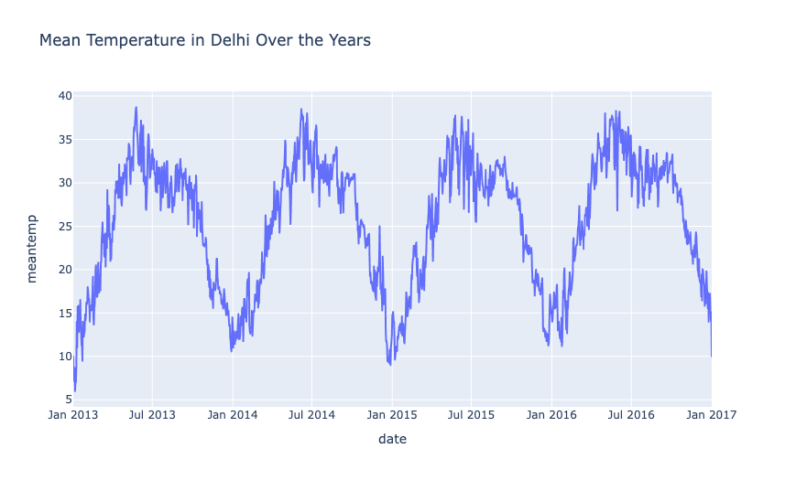

Fig:5.1

Now let’s have a look at the humidity in Delhi over the years:

**figure = px.line(data, x="date",**

**y="humidity",**

**title='Humidity in Delhi Over the Years')**

**figure.show()**

Now let’s have a look at the humidity in Delhi over the years:[7]

**figure = px.line(data, x="date",**

**y="humidity",**

**title='Humidity in Delhi Over the Years')**

**figure.show()**

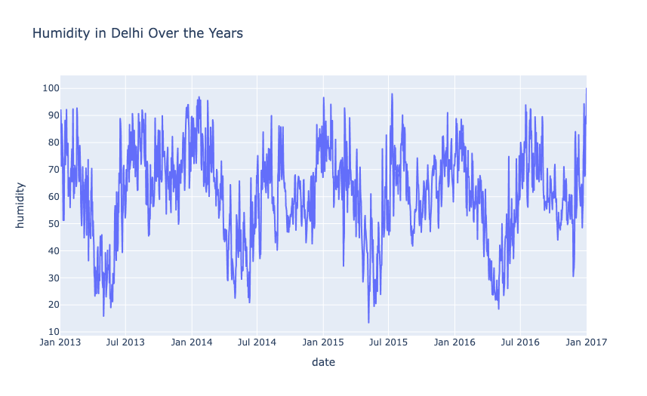

Fig:5.2

Now let’s have a look at the wind speed in Delhi over the years:

**figure = px.line(data, x="date",**

**y="wind_speed",**

**title='Wind Speed in Delhi Over the Years')**

**figure.show()**

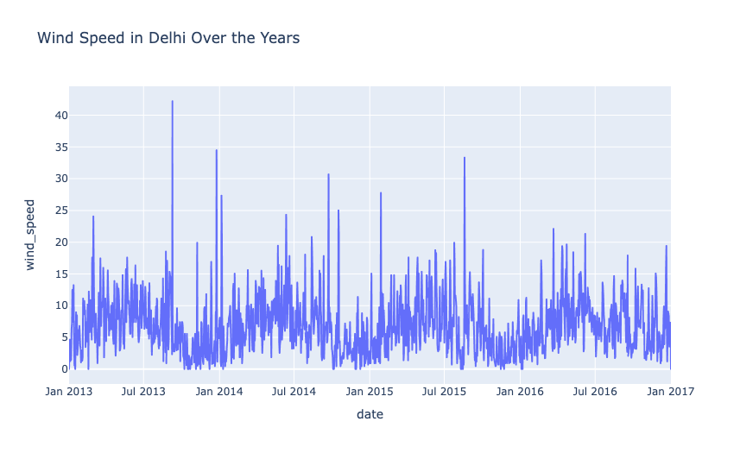

Fig:5.3

Till 2015, the wind speed was higher during monsoons (August & September) and retreating monsoons (December & January). After 2015, there were no anomalies in wind speed during monsoons. Now let’s have a look at the relationship between temperature and humidity:

**figure = px.scatter(data_frame = data, x="humidity",**

**y="meantemp", size="meantemp",**

**trendline="ols",**

**title = "Relationship Between Temperature and Humidity")**

**figure.show()**

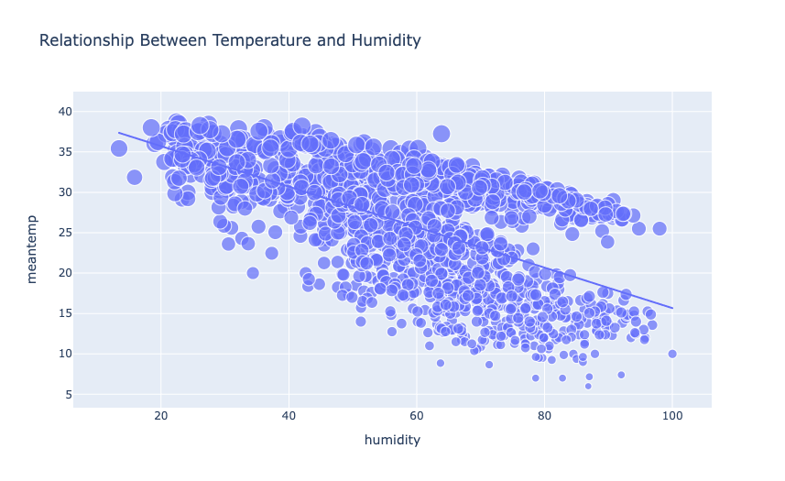

Fig:5.4

There’s a negative correlation between temperature and humidity in Delhi. It means higher temperature results in low humidity and lower temperature results in high humidity.

## Analyzing Temperature Change

Now let’s analyze the temperature change in Delhi over the years. For this task, I will first convert the data type of the date column into datetime. Then I will add two new columns in the dataset for year and month values.

Here’s how we can change the data type and extract year and month data from the date column:

data["date"] = pd.to_datetime(data["date"], format = '%Y-%m-%d')

data['year'] = data['date'].dt.year

data["month"] = data["date"].dt.month

print(data.head())

**date meantemp humidity windspeed meanpressure year month**

**0 2013-01-01 10.000000 84.500000 0.000000 1015.666667 2013 1**

**1 2013-01-02 7.400000 92.000000 2.980000 1017.800000 2013 1**

**2 2013-01-03 7.166667 87.000000 4.633333 1018.666667 2013 1**

**3 2013-01-04 8.666667 71.333333 1.233333 1017.166667 2013 1**

**4 2013-01-05 6.000000 86.833333 3.700000 1016.500000 2013 1**

Now let’s have a look at the temperature change in Delhi over the years:

**plt.style.use('fivethirtyeight')**

**plt.figure(figsize=(15, 10))**

**plt.title("Temperature Change in Delhi Over the Years")**

**sns.lineplot(data = data, x='month', y='meantemp', hue='year')**

**plt.show()**

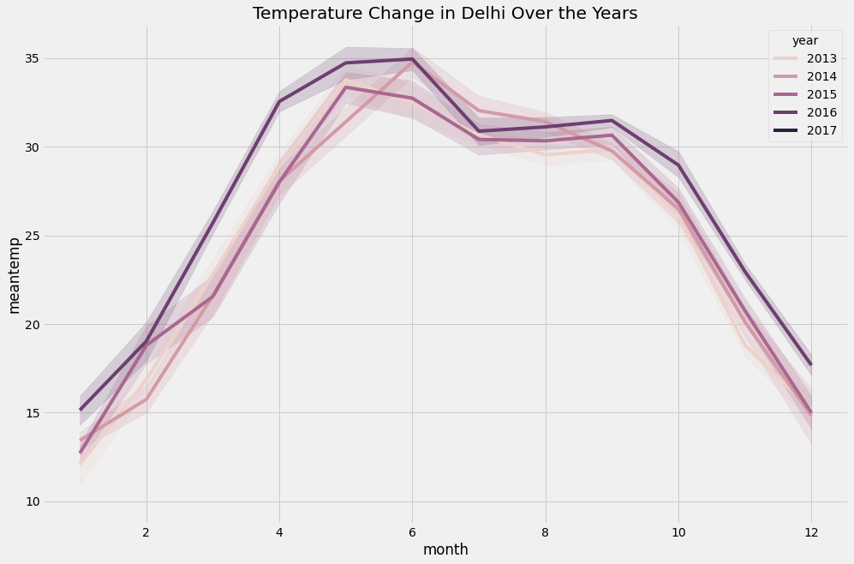

Fig:5.5

Although 2017 was not the hottest year in the summer, we can see a rise in the average temperature of Delhi every year.

Now let’s move to the task of weather forecasting. I will be using the Facebook prophet model for this task. The Facebook prophet model is one of the best techniques for time series forecasting. If you have never used this model before, you can install it on your system by using the command mentioned below in your command prompt or terminal:

* pip install prophet

The prophet model accepts time data named as “ds”, and labels as “y”. So let’s convert the data into this format:

forecast_data = data.rename(columns = {"date": "ds",

"meantemp": "y"})

print(forecast_data)

Now below is how we can use the Facebook prophet model for weather forecasting using Python:

**from prophet import Prophet**

**from prophet.plot import plot_plotly, plot_components_plotly**

**model = Prophet()**

**model.fit(forecast_data)**

**forecasts = model.make_future_dataframe(periods=365)**

**predictions = model.predict(forecasts)**

**plot_plotly(model, predictions)**

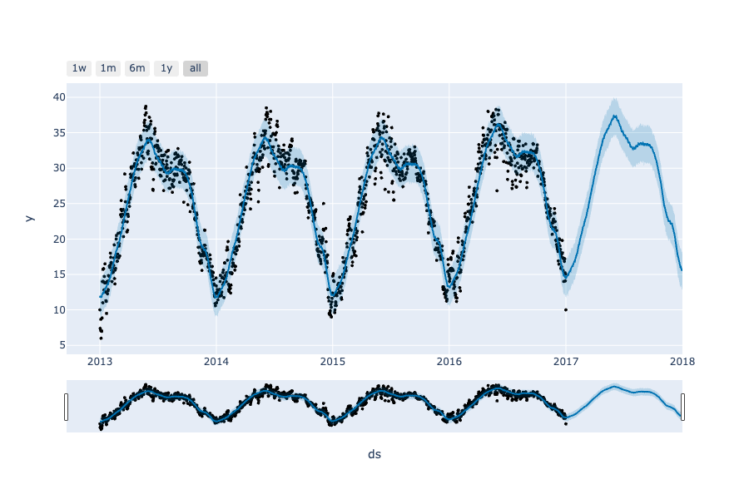

Fig:5.6

So this is how you can analyze and forecast the weather using Python.

**CHAPTER 6**

**CODE FOR WEATHER FORECASTING**:

#Weather report

#Importing Beautifulsoup Library

from bs4 import BeautifulSoup

#importing requests module

import requests

#header user agent is a string allows the server to identify the O.S and applicationheaders = {'User-Agent': 'Mozilla/5.0 (Windows NT 10.0; Win64; x64) AppleWebKit/537.36' (KHTML, like Gecko) Chrome/58.0.3029.110 Safari/537.3'}

#defining the weather function

def weather(city):

# Replaces the space with + operator

city=city.replace(" ","+")

#requests and get function to get the information from the URL provided

res=requests.get(f'https://www.google.com/search?q={city}&oq={city}’

f'&aqs=chrome.0.35i39l2j0l4j46j69i60.6128j1j7&sourceid='

f'chrome&ie=UTF-8',headers=headers)

#searches the information from google

print("Searching in google......\n")

#Navigates on that particular website ,extract and store the data in soup object

soup = BeautifulSoup(res.text,'html.parser')

#gets the information of location

location = soup.select('#wob_loc')[0].getText().strip()

#gets the information of time

time = soup.select('#wob_dts')[0].getText().strip()

#gets the desired information

info = soup.select('#wob_dc')[0].getText().strip()

#gets the weather information

weather = soup.select('#wob_tm')[0].getText().strip()

#prints location

print(location)

#prints time

print(time)

#prints the weather in degree celcius

print(weather+"°C")

#enter the city name

print("enter the city name")

city=input()

#Concatenating the city name and weather

city=city+" weather"

#passing the city object to weather function

weather(city)

import requests

city = input(‘input the city name:’)

print(city)

print(‘Displaying Weather report for: ‘ + city)

url = ‘https://wttr.in/{}’.format(city)

res = requests.get(url)

print(res)

data = res.data

print(data)[8]

**CHAPTER 7**

**RESULT AND DISCUSSION:**

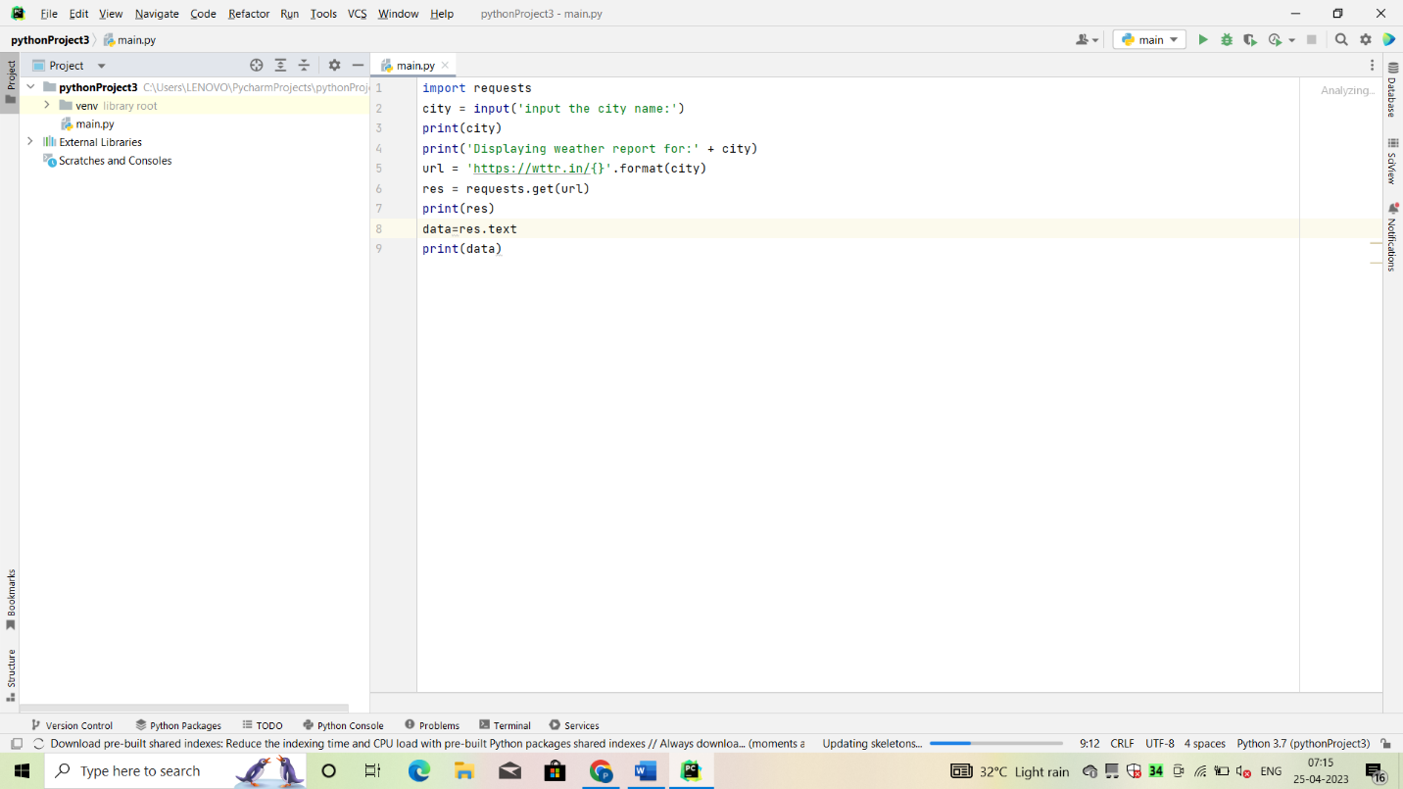

Fig:7.1

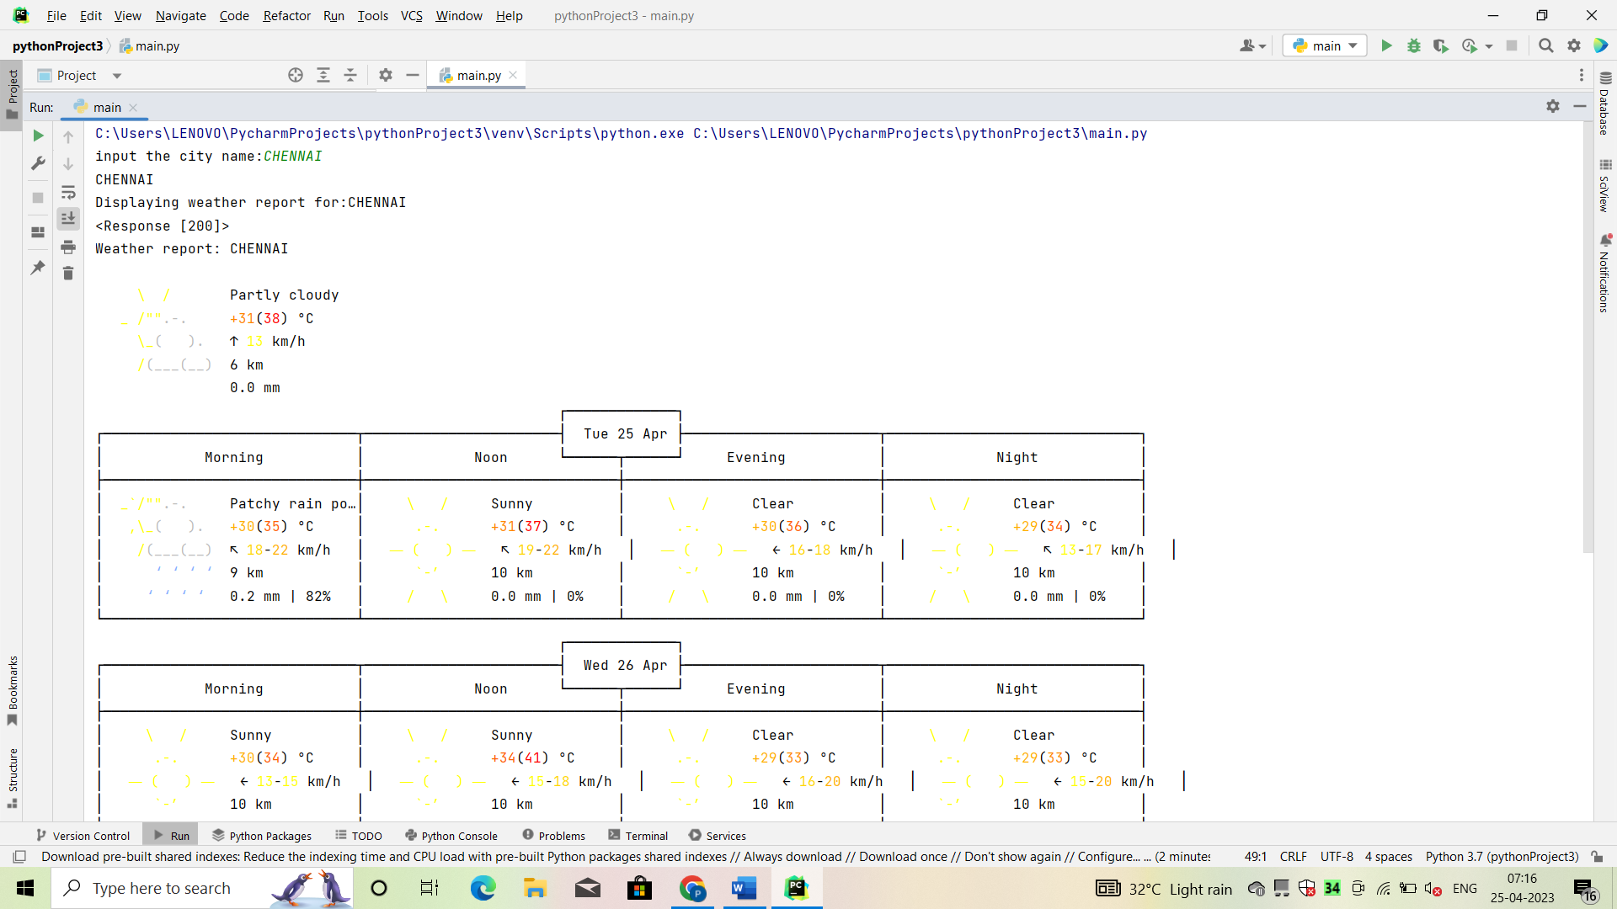

Fig:7.2

**EXPLANATION:**

In this module we first gather the data(dataset) for our prediction model. Data comes in all forms, most of it being very messy and unstructured. They rarely come ready to use. Datasets, large and small, come with a variety of issues- invalid fields, missing and additional values, and values that are in forms different from the one we require. In order to bring it to workable or structured form, we need to “clean” our data, and make it ready to use. Some common cleaning includes parsing, converting to one-hot, removing unnecessary data, etc. In our case, our data has some days where some factors weren’t recorded. And the rainfall in cm was marked as T if there was trace precipitation. Our algorithm requires numbers, so we can’t work with alphabets popping up in our data. So we need to clean the data before applying it on our model.[9]

Once the data is cleaned, In this module that cleaned data can be used as an input to our Linear regression model. Linear regression is a linear approach to form a relationship between a dependent variable and many independent explanatory variables. This is done by plotting a line that fits our scatter plot the best, ie, with the least errors. This gives value predictions, ie, how much, by substituting the independent values in the line equation.

We will use Scikit-learn’s linear regression model to train our dataset. Once the model is trained, we can give our own inputs for the various columns such as temperature, dew point, pressure, etc. to predict the weather based on these attributes.

**MODULE OUTCOMES:**

1). By the end of the first module the fully cleaned and useful data is available for the apply the algorithm for the prediction.

2). By the end of the second module the actual prediction will be happen the outcome is the amount of rainfall in inches based upon the use.[10]

**CONCLUSION**

## We successfully predicted the rainfall using the linear regression but here this is not very accurate only sometimes any way it depends upon the climate changes to season to season. Here we are taking only summer season weather data set it only useful to predict rainfall in summer season. Finally, it is agreed that we made an attempt on the following points:

* The description of the purpose the scope and applicability of this project.
* We specify the system’s necessary specs as well as the actions that can be performed on these objects.
* We define the system’s required specifications and the actions that can be taken on these objects.
* We comprehend the problem domain and create a system model that represents the operations that can be performed on the system.
* We went into great lengths about the features and processes, providing a lot of important information.
* We created the user interface as well as system security issues.
* Finally, the system is built and tested in accordance with the test cases.[11]

**CHAPTER 8**

**REFERENCES**

[1] DR.C.K.Gomathy , V.Geetha , S.Madhumitha , S.Sangeetha , R.Vishnupriya Article: A Secure With Efficient Data Transaction In Cloud Service, Published by International Journal of Advanced Research in Computer Engineering & Technology (IJARCET) Volume 5 Issue 4, March 2016, ISSN: 2278 – 1323.

[2] Dr.C.K.Gomathy,C K Hemalatha, Article: A Study On Employee Safety And Health Management International Research Journal Of Engineering And Technology (Irjet)- Volume: 08 Issue: 04 | Apr 2021.

[3] Dr.C K Gomathy, Article: A Study on the Effect of Digital Literacy and information Management, IAETSD Journal For Advanced Research In Applied Sciences, Volume 7 Issue 3, P.No-51-57, ISSN NO: 2279-543X,Mar/2018.

[4] Dr.C K Gomathy, Article: An Effective Innovation Technology In Enhancing Teaching And Learning Of Knowledge Using Ict Methods, International Journal Of Contemporary Research In Computer Science And Technology (Ijcrcst) E-Issn: 2395-5325 Volume3, Issue 4,P.No-10-13, April ’2017.

[5] Dr.C K Gomathy, Article: Supply chain-Impact of importance and Technology in Software Release Management, International Journal of Scientific Research in Computer Science Engineering and Information Technology ( IJSRCSEIT )Volume 3 | Issue 6 | ISSN : 2456-3307, P.No:1-4, July-2018.

[6] C K Gomathy and V Geetha. Article: A Real Time Analysis of Service based using Mobile Phone Controlled Vehicle using DTMF for Accident Prevention. International Journal of Computer Applications 138(2):11-13, March 2016. Published by Foundation of Computer Science (FCS), NY, USA,ISSN No: 0975-8887.

[7] C K Gomathy and V Geetha. Article: Evaluation on Ethernet based Passive Optical Network Service Enhancement through Splitting of Architecture. International Journal of Computer Applications 138(2):14-17, March 2016. Published by Foundation of Computer Science (FCS), NY, USA, ISSN No: 0975-8887.

[8] C.K.Gomathy and Dr.S.Rajalakshmi.(2014), “A Software Design Pattern for Bank Service Oriented Architecture”, International Journal of Advanced Research in Computer Engineering and Technology(IJARCET), Volume 3,Issue IV, April 2014,P.No:1302-1306, ,ISSN:2278-1323.

[9] C. K. Gomathy and S. Rajalakshmi, “A software quality metric performance of professional management in service oriented architecture,” Second International Conference on Current Trends in Engineering and Technology – ICCTET 2014, 2014, pp. 41-47, doi: 10.1109/ICCTET.2014.6966260.

[10] Dr.C K Gomathy, V Geetha, T N V Siddartha, M Sandeep, B Srinivasa Srujay Article: Web Service Composition in a Digitalized Health Care Environment For Effective Communications, Published by International Journal of Advanced Research in Computer Engineering & Technology (IJARCET) Volume 5 Issue 4, April 2016, ISSN: 2278 – 1323.

[11] Dr.C K Gomathy, V Geetha, T.Jayanthi, M.Bhargavi, P.Sai Haritha Article: A Medical Information Security Using Cryptosystem For Wireless Sensor Networks, International Journal Of Contemporary Research In Computer Science And Technology (Ijcrcst) E-Issn: 2395-5325 Volume3, Issue 4, P.No-1-5,April ’2017.



